
SHIRE HIGHLANDS EDUCATION DIVISION
2026 MALAWI SCHOOL CERTIFICATE OF EDUCATION MOCK
EXAMINATION

BIOLOGY
Subject Number: M022/I
Tuesday, 17 March Time Allowed: 2 hours
8:00-10:00am

PAPER I
(100 Marks)

THEORY
Question Number | Tick if answered | Do not write these columns
1
2
3
4
5
6
7
8
9
10
11
12
13
TOTAL
Instructions
- This paper contains 11 printed pages. Please check.
- Before you begin, fill your Name at the top of each page in the spaces provided.

- This paper has two sections; A and B. Section A has ten questions and Section B has three questions.

- Answer all the 11 questions in the spaces provided. The maximum number of marks for each question is indicated against each question.

- In the table provided on this page, tick against the question number you have answered.

Turn Over
SECTION A (70 MARKS)
1 a. Define the term oxygen debt.
________________________________________________________________
(1 mark)
b. Below is the chemical equation of a certain chemical reaction that occurs in the human cell. Use it to answer questions that follow.
C₆H₁₂0₂ + 60₂ 6C0₂ ₊ 6H₂0 + Energy
i. Mention part of the cell in which the above process occurs
___________________________________________________________
(1 mark)
ii. State any three way in which the produced energy is utilized.
______________________________________________________________________________________________________________________
(2 marks)
2 a. Figure below shows a plant response to a stimulus.
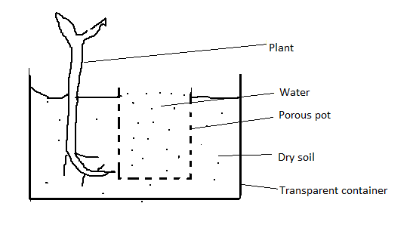
- Identify the stimulus in the above illustration.
___________________________________________________________
(1 marks)
ii. Explain one importance of the above response
______________________________________________________________________________________________________________________
(2marks)
b. Explain how nastic responses occur in Mimosa pudica plant.
________________________________________________________________________________________________________________________________
(2 marks)
c. i. Explain any two functional differences between brain and the spinal cord.
____________________________________________________________________________________________________________________________________________________________________________________________________________________________________________
4 marks
- State any two importance of vaccine.
______________________________________________________________________________________________________________________
2 marks
3 a. State any two adaptation of mammals for locomotion.
________________________________________________________________________________________________________________________________
(2marks)
b. Below is a diagram of a stage of meiosis cell division. Use it to answer questions that follow.
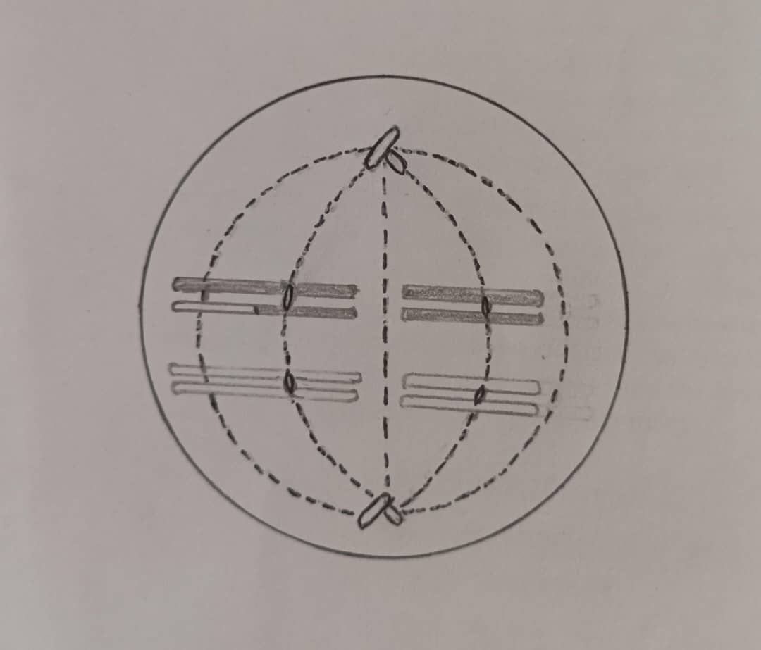
i. What stage of meiosis is represented by the figure above?
__________________________________________________________
(1 mark)
ii. Explain any two significance of meiosis.
____________________________________________________________________________________________________________________________________________________________________________________________________________________________________________ (4 marks)
c. Mention any two genes that determine blood groups in humans
i_______________________________________________________________
ii_______________________________________________________________
(2 marks
4 a. The following is a flow diagram of menstrual cycle. Use it to answer questions
that follow.
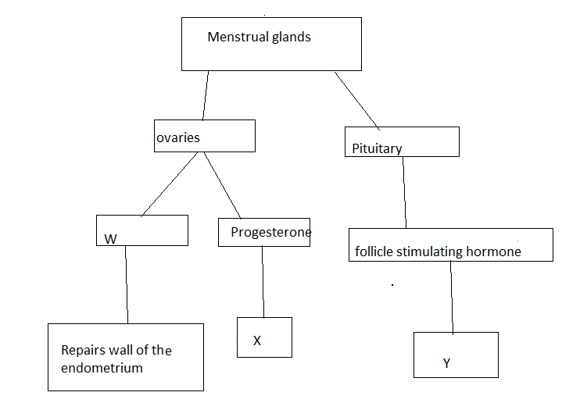
i. Mention the hormone represented by W
___________________________________________________________
(1 mark)
ii. State functions X and Y X_________________________________________________________
(1 mark)
Y_________________________________________________________
(1 mark)
b. Describe what happens in the menstrual cycle on.
i. Day 1
______________________________________________________________________________________________________________________(2 marks)
ii.Day 14.

________________________________________________________________________________________________________________________________
(2 marks)
c. Mr and Mrs Phiri are individuals with normal black skin. To their surprise, they have given birth to child with albinism. Use this information to answer questions that follow.
i. Explain the cause of the above genetic disorder?
_____________________________________________________________________________________________________________________
(2 marks)
ii. What name is given to a service that could be provided to the couple to understand their situation?
__________________________________________________________
(1 mark)
5 a. In what form do the following absorb nitrogen?
i. Green plants
___________________________________________________________ (1 mark)
ii. Animals
___________________________________________________________
(1 mark)
b. Explain how the following affect the distribution of organisms in an ecosystem.
i. Soil
______________________________________________________________________________________________________________________
(2 marks)
ii. Temperature
______________________________________________________________________________________________________________________
(2 marks)
c. Describe the depletion of ozone layer as an effect of air pollution.
________________________________________________________________________________________________________________________________________________________________________________________________________________________________________________________________
(3 marks)
6 a. Explain the function of tonsils as lymphatic organs.
________________________________________________________________________________________________________________________________
(2 marks)
b. Describe the following conditions associated with circulatory system
i. Varicose veins
______________________________________________________________________________________________________________________
(2 marks)
ii. Arteriosclerosis
_______________________________________________________________________________________________________________________________
(2 marks)
7 a. Define the term speciation.
_______________________________________________________________
(1 mark)
b. Explain any one way in which speciation occurs.
________________________________________________________________________________________________________________________________________________________________________________________________
(2 marks)
8. Below is the figure showing the human urinary system. Use it to answer questions that follows.

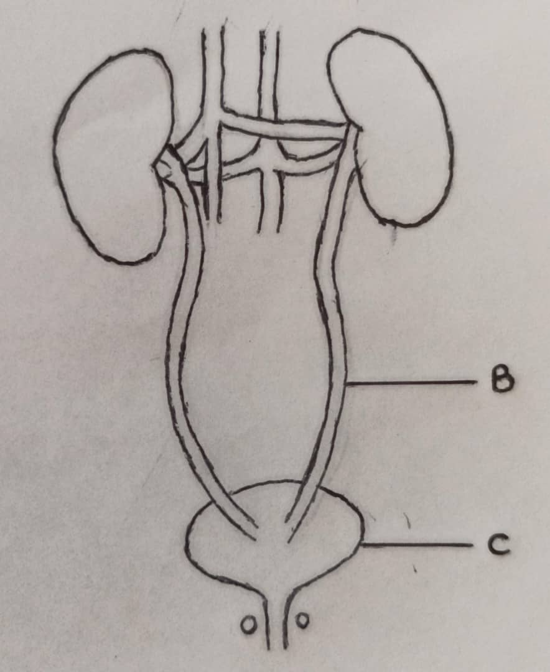
a. Name the parts labelled B and C
B______________________________________________________________
(1 mark)
C_____________________________________________________________
(1 mark)

b. Explain how ADH controls low water contents in blood.
______________________________________________________________________________________________________________________________________________________________________________________________________________________________________________________________________________________________________________________ (5 marks)
9. Below is a figure showing transverse section through a young root. Use it to answer questions that follow.

Y

X

- What tissues are represented by letters X and Y
X_________________________________________________________________
(1 mark)
Y__________________________________________________________________
(1 mark)
b. Explain the function of part X in photosynthesis
________________________________________________________________________________________________________________________________
(2 marks)
c. Describe the carbon dioxide fixation in photosynthesis process.
________________________________________________________________________________________________________________________________ (2 marks)
10 a i. Mention the name of the hormone produced by the thyroid gland
___________________________________________________________
(1 mark)
ii. State the function of the hormone mentioned above
__________________________________________________________
(1 mark)
c. Briefly explain how pancreas controls high level of glucose in the blood.
________________________________________________________________________________________________________________________________
(3 marks)
SECTION B (30 MARKS)
Answer all questions in this section, your answers should be in an essay form.
11. Explain any five ways of preventing diseases at household level.
_____________________________________________________________________________________________________________________________________________________________________________________________________________________________________________________________________________________________________________________________________________________________________________________________________________________________________________________________________________________________________________________________________________________________________________________________________________________________________________________________________________________________________________________________________________________________________________________________________________________________________________________________________________________________________________________________________________________________________________________________________________________________________________________________________________________________________________________________________________________________________________________________________________________________________________________________________________________________________________________________________________________________________________________________________________________________________________________________
(10 marks)
12. Outline steps how insulin is formed through genetic engineering.
__________________________________________________________________________________________________________________________________________________________________________________________________________________________________________________________________________________________________________________________________________________________________________________________________________________________________________________________________________________________________________________________________________________________________________________________________________________________________________________________________________________________________________________________________________________________________________________________________________________________________________________________________________________________________________________________________________________________________________________________________________________________________________________________________________________________________________________________________________________________________________________________________________________________________________________________________________________________________________________________________________________________________________________________________________________________________________________________________________________________________________________________________________________________________________________________________________________________________________________________________________________________________________________________________________________________________________________________________________________________________________________________________________________________________________________________________________________________________________________________________________________________________________________________________________________________________________________________________________________________________________________________________________________________________________________________________________________________________________________________________________________________________________________________________________________________________________________________________________________________________________________________________________
(10 marks)
13. Outline any five ways in which xerophytes reduces rate of transpiration
________________________________________________________________________________________________________________________________________________________________________________________________________________________________________________________________________________________________________________________________________________________________________________________________________________________________________________________________________________________________________________________________________________________________________________________________________________________________________________________________________________________________________________________________________________________________________________________________________________________________________________________________________________________________________________________________________________________________________________________________________________________________________________________________________________________________________________________________________________________________________________________________________________________________________________________________________________________________________________________________________________________________________________________________________________________________________________________________________________________________________________________________________________________________________________________________________________________________________________________________________________________________________________________________________________________________________________________________________________________________________________________________________________________________________________________________________________________________________________________________________________________________________________________________________________________________________________________________________________________________________________________________________________________________________________________________________________________________________________________________________________________________________________________________________________________________________________________________
(10 marks)
END OF QUESTION PAPER

